the green line, display the game menu for the player’s to play, such as, play game, how to play, scores, about game and exit. As well as the player’s game result, when the game was over. When the player choose to “play the game”, the players can start his journey to slicing the falling fruits of the game and make his best records, and when the game was over, the player should enter his name and store it to the system database. If the player choose to “how to play”, the game display the game instruction. If the player choose to “scores”, the game display the three (3) highest scores of the game. If the player choose to “about game”, the game display the history or about the game. And if the player choose to “exit”, the game exit automatically.

The yellow line represents how the game works. It shows that the fruits mangoesteen, papaya, pomelo and atis have a corresponding of one (1) point. In every sliced fruits, the player gained the points. To gain the points the player need to collide consistently the object motion sword to the falling fruits of the game. The game has a special features which is special fruits with extraordinary points.The mango fruits has a corresponding five (5) points and durian fruit has a point multiplier. When the player sliced the durian fruits, all of the falling fruits is multiplied by two.

Lastly, the red line shows all the data entered by the player store to the system database such as, the player’s name and the player’s scores. Also the game retrieved the data from the system database to show the results of the player’s game.

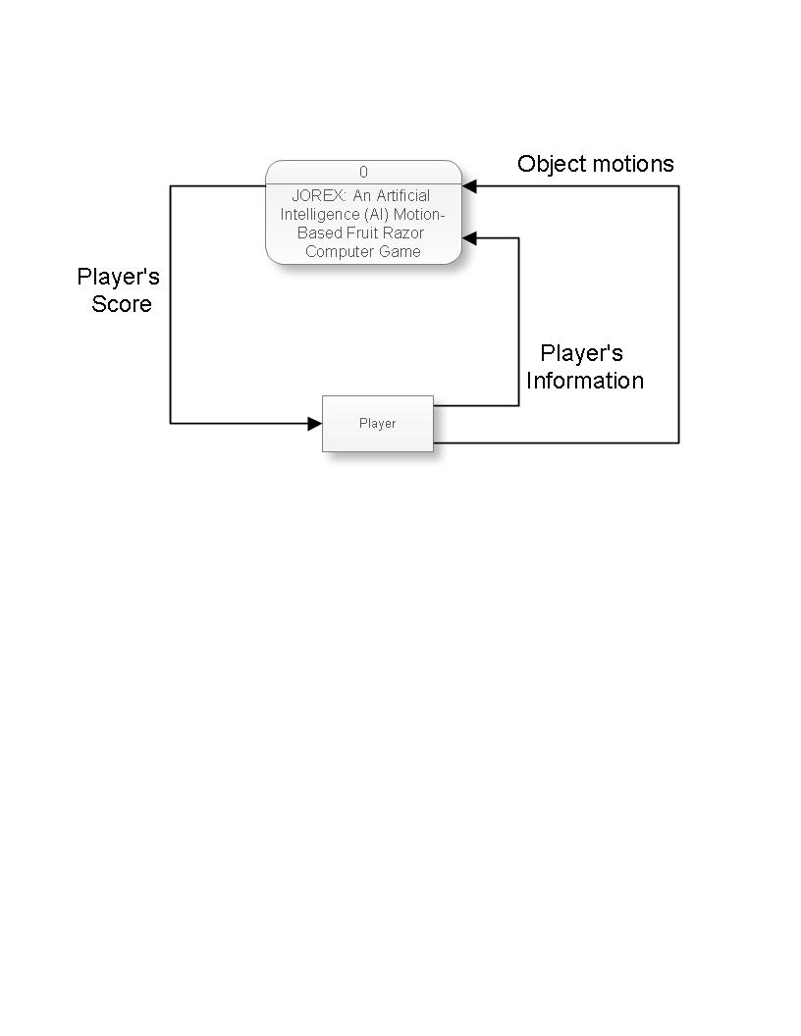

*Figure 4.1.2* Schema of Jorex: An Artificial Intelligence (AI) Motion-based Fruit Razor Computer Game

Figure 4.1.2 demonstrates the flow of an artificial intelligence (AI) motion-based fruit razor computer game. The player inputs information into the game such as his name, then he can now play. The object motion represents the sword to detect and slice the falling fruits and acquire scores .When the player sliced the bomb or missed slicing the falling fruits, the game should be over and the game shows the player’s score.

**4.2 Hardware and Software Requirements**

This section shows the hardware and software specification in the study.

*Table 4.2.1.* Hardware and Software Requirements

|  |  |
| --- | --- |
| **PARTICULAR** | **SPECIFICATION** |
| **Software** | |
| Python | A web browser (to download python on and to google future questions) Python (Welcome to Python.org) < 2.6 (python 3 is wonderful) A text editor |
| Sublime Text 3 | Operating System: Windows XP, Windows Vista or Windows 7/8/8.1/10. RAM (Installed Memory): Minimum 512MB. Free Space on Hard Disk: 100MB minimum for installation. |
| Open CV | An image processing library created by intel and maintained by millow garage. An open source and free available in c, c++, and python. Easy to use and install. It has C++, C, Python and Java interfaces and supports Windows, Linux, Mac OS, iOS and Android. OpenCV was designed for computational efficiency and with a strong focus on real-time applications. |
| **Hardware** | |
| Laptop Computer | Intel Core ROG-GL552VX Processor (3M Cache, 2.0GHz),Windows 10, 4GB DDR4L 2113 MHz SDRAM, 15.6-inch 16:9 HD (3840x2116) Display, NVIDIA GeForce 950M with 2GB DDR5 VRAM, 1TB HDD, Super-Multi DVD, 3 -in-1 card reader ( SD/ SDHC/ SDX, VGA Web Camera, Integrated, Built-in Bluetooth™ V4.0 (Optional) |
| **PARTICULAR** | **SPECIFICATION** |
| Camera | Max dynamic resolution: 2.0Mpixels (320x240, 640x480, 1280x720) Lens types: CMOSLens 3 million pixels Maximum frame number 30 framesColor digits 24 bits |

**4.3 Developmental Approach**

**4.3.1 Planning**

The researchers proposed to develop a new game entitled, JoRex: An Artificial Intelligence (AI) Motion-based Fruit Razor Computer Game. In developing this game, the researchers define some problems such as; sitting for prolonged period of time can cause heart disease and obesity, so the researchers proposed the alternative solutions. The researchers calculate the strength and weaknesses of the game, thus, they planned the resources, cost, time and profits.

**4.3.2 Analysis**

The researchers determined and documented the problems of players and their causes, effects, and solutions. They formulated the objectives of the study. The objectives served as guide to solve the problem of the study. The researchers identified the different devices or materials that were needed to fully develop this motion-based game.

**4.3.3 Design**

The researchers intended the Graphical User Interface (GUI), as well as its operational diagram and context diagram of the proposed game. They focused on testing the functionality of materials as well as the coding of the developed game. Also the researchers discussed and determined the needs of the proposed game development. The researchers considered the essential components such as hardware and software to accomplish its objectives.

**4.3.4 Implementation**

When the majority of the code for the program is written and with all materials are working properly, the researchers tested the developed game for its workability. At this stage, the results of the study were analysed. If the developed game runs smoothly on these systems without any flaw, then it is considered ready to be launched.

**4.3.5 Maintenance**

The researchers decided to have a monthly maintenance for the game which can be carried out to make sure that the game won’t be obsolete. This include upgrading the old software and continuously evaluating game’s performance. It also includes providing latest updates for certain components to make sure it meets the right standards and the latest technologies to face current security threats.

**4.4 Research Locale**

The research was conducted at the Notre Dame of Tacurong College, City of Tacurong. The respondents are randomly chosen from the college department of the same school. The developed game had been evaluated by the students of the institution through a survey questionnaire.

**4.5 Research Sampling**

The developed system uses probability sampling particularly Simple Random Sampling. The total number of respondents was determined using Slovin’s formula. The formula used was presented in equation number one.

$n=\frac{N}{1+N{(e)}^{2}}$ Equation 4.5.1

As presented, in equation number one uses three different variables, such as; the small letter “n” represents the sample size, the capital letter “N” represents population and the small letter “e” represents level of precision.

In this study, there were 637 college students enrolled in Notre Dame of Tacurong College, City of Tacurong. Applying the formula Equation 4.5.1:

$$n=\frac{637}{1+637 {(0.05)}^{2}}=246$$

The outcome represents that out of 637 college students, 246 who were randomly picked served as the respondents. A 5% sampling error was used since the 95% confidence level was applied.

**4.6 Research Instrument**

In gathering data, the study used survey questionnaire to evaluate the developed game’s accuracy in terms of cutting objects and adding its corresponding points, generating scores, adding bonus scores, and tracking the coordinates of sword location.

*Table 4.6.1.* Four-Point Likert Scale Model

|  |  |  |
| --- | --- | --- |
| SCALE | VERBAL INTERPRETATION | DEFINITION |
| 4 | Strongly Agree | Indicates the total agreement of the respondents in all statements to be written in the survey form. |
| 3 | Agree | Indicates the partial agreement of the respondents in all statements to be written in the survey form. |
| 2 | Disagree | Indicates the partial disagreement of the respondents in all statements to be written in the survey form. |
| 1 | Strongly Disagree | Indicates the total disagreement of the respondents in all statements to be written in the survey form. |

The table shows the Four-Point Likert Scale Model. It has a scale from four to one with each scale having its own corresponding verbal interpretation and definition. Four is interpreted as strongly agree and indicates total agreement, three which isinterpreted as agree, indicates partial agreement, two, interpreted as disagree indicates partial disagreement, and one for strongly disagree, which indicates total disagreement of the respondents in all the statement in the survey form.

**4.7 Statistical Treatment of Data**

Statistical treatment of data is very significant in all research studies as this determines and evaluates the performance of the developed system.

*Table 4.7.1* Evaluation’s Interpretation

|  |  |
| --- | --- |
| **SCALE** | **VERBAL INTERPRETATION** |
| 3.01-4.00 | Strongly Agree |
| 2.01-3.00 | Agree |
| 1.01-2.00 | Disagree |
| 0.00-1.00 | Strongly Disagree |

In this study, the researchers used survey questionnaire to collect data. These survey questionnaires are given to the respondents to answer. Mean is used to test the accuracy of the game. The Four-Point Likert Scale Model is used to interpret the result.

**4.8 Schedule and Timeline**

This section contains the Gantt chart showing the schedule and the timeline in making the project. It shows all the events scheduled for a particular work of the months for the school year 2017-2018.

*Table 4.8.1* Schedule in making the Developed Game

|  |  |  |  |  |  |  |  |  |  |  |
| --- | --- | --- | --- | --- | --- | --- | --- | --- | --- | --- |
| **ACTIVITY** | **June** | **July** | **August** | **September** | **October** | **November** | **December** | **January** | **February** | **March** |
| Planning of the  System |  |  |  |  |  |  |  |  |  |  |
| Group discussion about the System planned |  |  |  |  |  |  |  |  |  |  |
| Identifying the task of the member of the group |  |  |  |  |  |  |  |  |  |  |
| Researching and gathering information of the related System |  |  |  |  |  |  |  |  |  |  |
| Designing and Analysing of different Algorithm |  |  |  |  |  |  |  |  |  |  |
| Discussing of the front end of the System |  |  |  |  |  |  |  |  |  |  |
| 70% of the system is already been working |  |  |  |  |  |  |  |  |  |  |
| Designing of Graphic User Interface |  |  |  |  |  |  |  |  |  |  |
| Programming of the system |  |  |  |  |  |  |  |  |  |  |
| 100% of the system is ready and working properly |  |  |  |  |  |  |  |  |  |  |
| Implementation of the final project |  |  |  |  |  |  |  |  |  |  |

On the month of July the researchers were planning to develop a game entitled Artificial Intelligence (AI) Motion-based Fruit Razor Computer Game. On the month of August to September the researchers discussed about the related developed games such as fruit ninja and [Multiplayer Online Battle Arena](https://en.wikipedia.org/wiki/Multiplayer_online_battle_arena) (MOBA) video game at the same time identify the member of the group that should be in the programming field and designing. The system begun to program so that the researchers identified the errors and track the shortage of the system continuing until November. After discussing about the system, on September the researchers identified the different analysis of different algorithm. On the month of October the researchers created their front end at the same time the system should be 70% working. The 100% of the system is working and ready to use by the selected respondents on November. On December to March the researchers implemented their developed game.

**4.9 Budgetary Outlay**

This section presents the budget and costs of the equipment that the researchers had incurred to create the JoRex: An AI Motion-Based Fruit Razor Computer Game. It shows the budgetary outlay which shows the list of all items and the total costs needed to accomplish the project.

*Table 4.9.1.* Budget and Proper Cost Management in making the developed game.

|  |  |  |  |
| --- | --- | --- | --- |
| **Particular** | **Quantity** | **Unit Price**  **(₱)** | **Total**  **(₱)** |

|  |  |  |  |
| --- | --- | --- | --- |
| **Hardware** |  | | |
| Laptop Computer | 1 | 27,000.00 | 27,000.00 |
| Ball | 1 | 50.00 | 50.00 |
| **Particular** | **Quantity** | **Unit Price**  **(₱)** | **Total**  **(₱)** |
| Sword | 1 | 200.00 | 200.00 |
| **Software** |  | | |
| Sublime 3(Open Source) | - | - | - |
| Python (Open Source) | - | - | - |
| **Man Power** |  | | |
| Labor Cost |  |  | ₱ 219,600.00 |
| **Total Cost** | | | **₱ 246,850.00** |

Table 4.9.1 shows the budget and proper cost management in making the developed game. It shows the particular hardware such as laptop computer, ball, sword, and software such as sublime 3 and python and manpower with labor cost, as well as its quantities, unit prices and the total cost of every hardware, software and manpower.

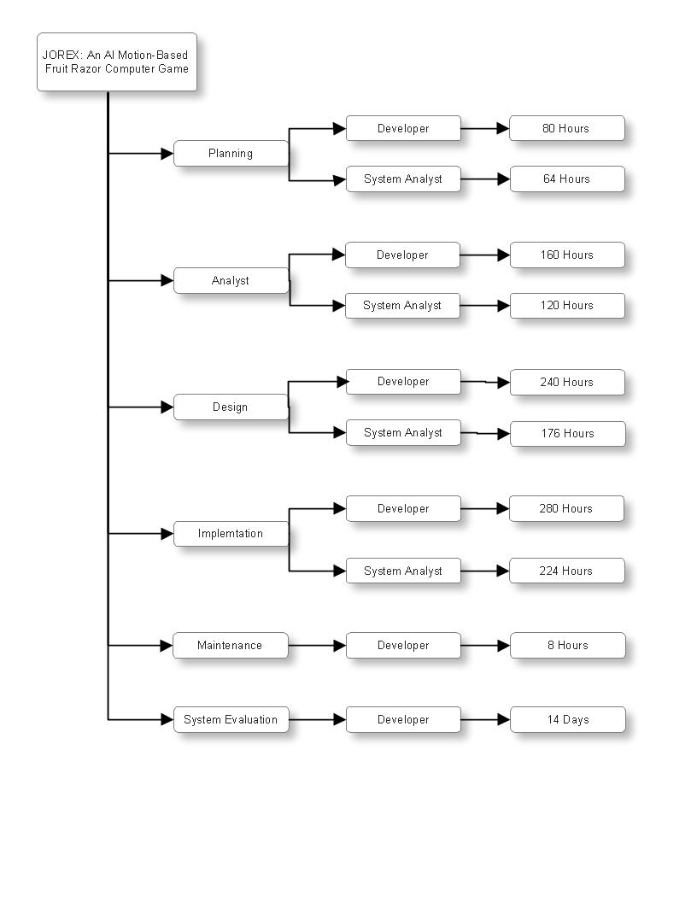



*Figure 4.9.2* Work Breakdown Structure (WBS) of the JoRex: An AI Motion-Based Fruit Razor Computer Game

The figure illustrates the work breakdown structure of the game developed, it is the procedure were the researchers planned, analysed, designed, implemented, maintenances, and evaluates the system. It also shows who of the personnel will be the developer and system analyst. Also the figure displays the hours consumed by the developer and system analyst.

*Table 4.9.3*Costs of labor based on the Work Breakdown Structure of the Project.

|  |  |  |  |
| --- | --- | --- | --- |
| **Personnel** | **Rate per hour**  **(₱)** | **Total hours rendered** | **Total rate**  **(₱)** |
| Developer | 150.00 | 880 hrs. | 132,000.00 |
| System Analyst | 150.00 | 584 hrs. | 87,600.00 |
|  |  | **TOTAL** | **₱ 219,600.00** |

The table above shows the overall labor costs based on the work breakdown structure of the game developed. The personnel of the game developed is composed of two, the developer and the system analyst. Also the table indicate the rate per hour (Php) of the personnel. The total rate of the hours rendered are shown as well as the total rate that has been added by rate per hour and total hours rendered.